|  |  |  |  |  |  |  |
| --- | --- | --- | --- | --- | --- | --- |
| **Mehran University of Engineering & Technology,**  **Jamshoro** | |  | **Subject** | | | |
| **Web Technology** | | | |
| **Department of:**  **Bachelor of Science Computer Science** | | **Year** | **2nd** | **Semester** | **3rd** |
| **Roll No:** | **20BSCS043** | **Batch** | **20BSCS** | **Duration** | **3 Hours** |

**PRACTICAL # 10**

**TO EXECUTE THE SERVER-SIDE LANGUAGE (PHP)**

**Task # 1:** Make A Simple Mark sheet Program using PHP Give Subject Name and Marks using Variables and echo it in HTML Table

**Code:**

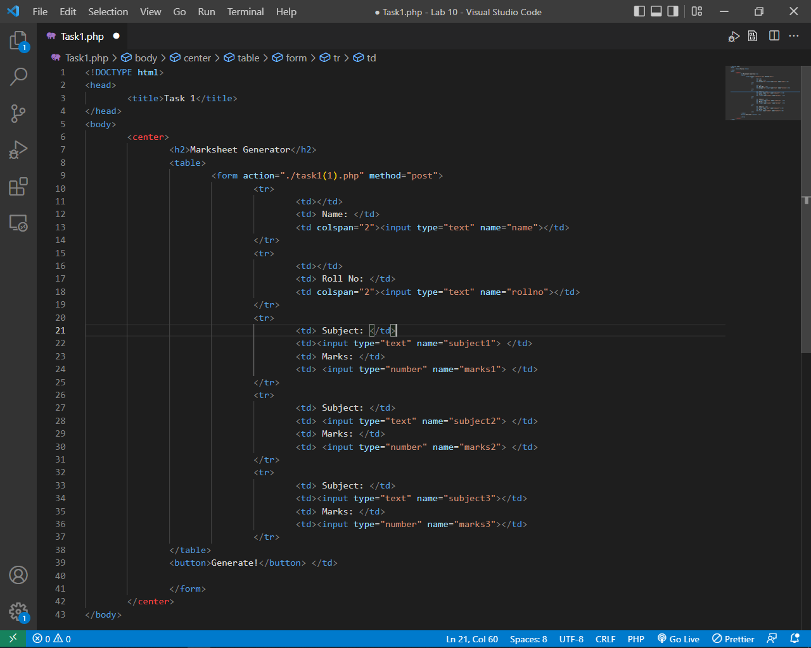

File # 1

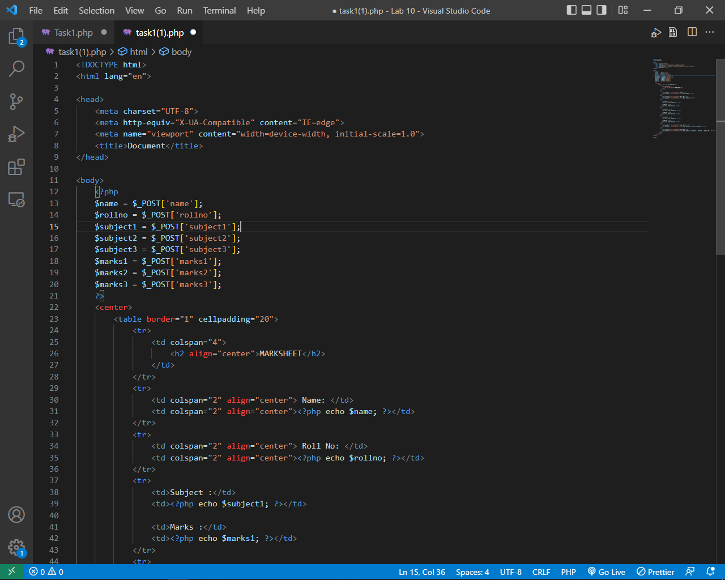

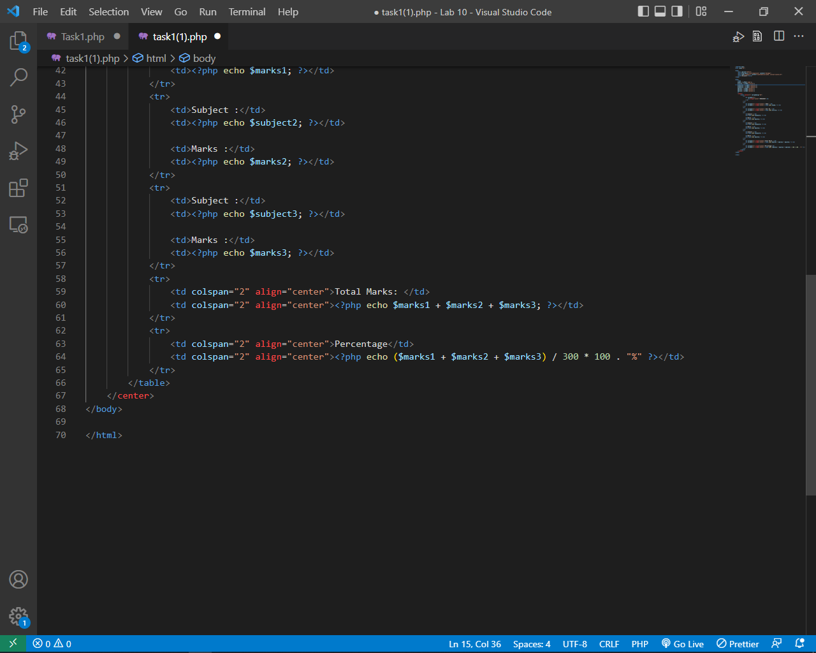

File # 2

**Output:**

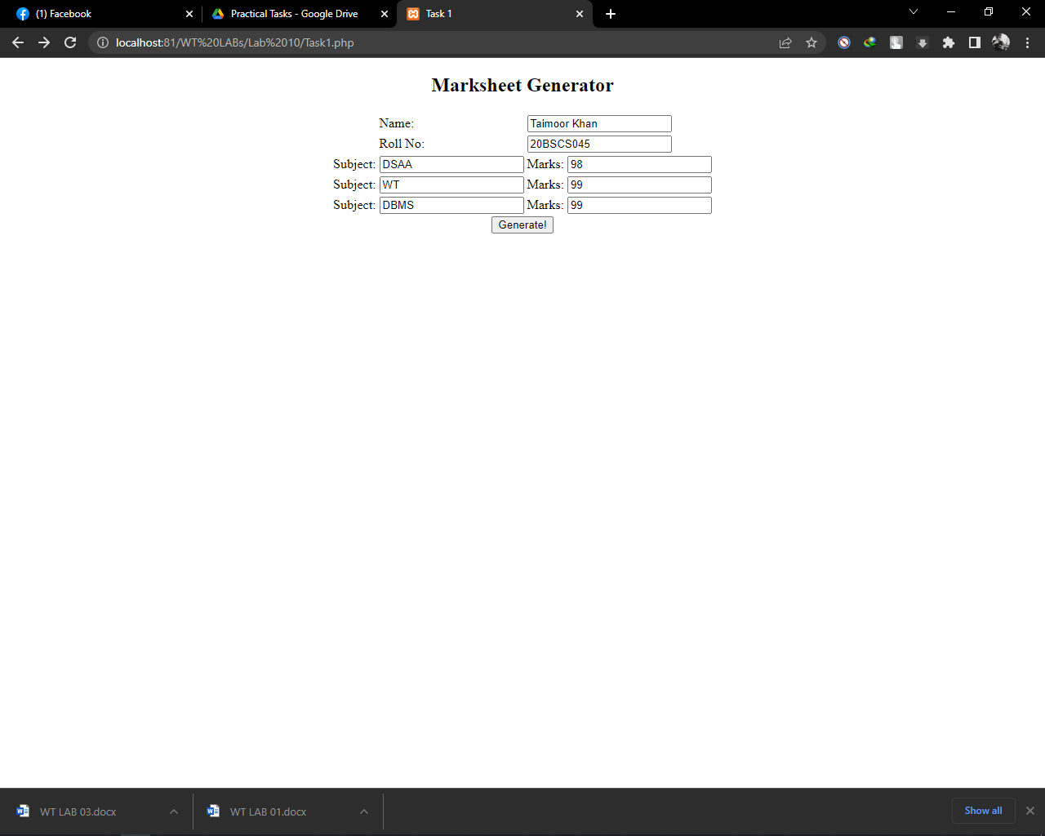

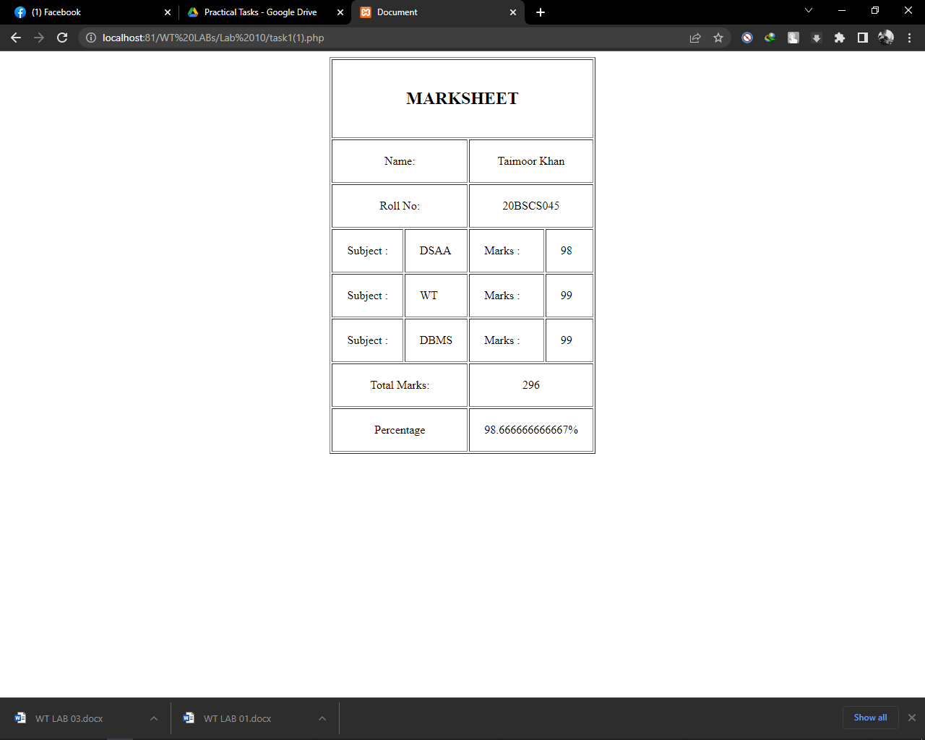

**Task # 2:** : Make validation form, in which student’s data (Name, Roll #, Class & Section) mandatory to be filled using PHP.

**Code:**

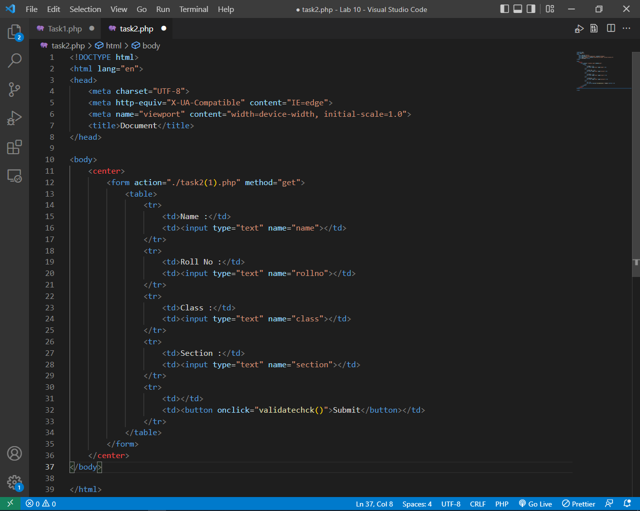

File # 1

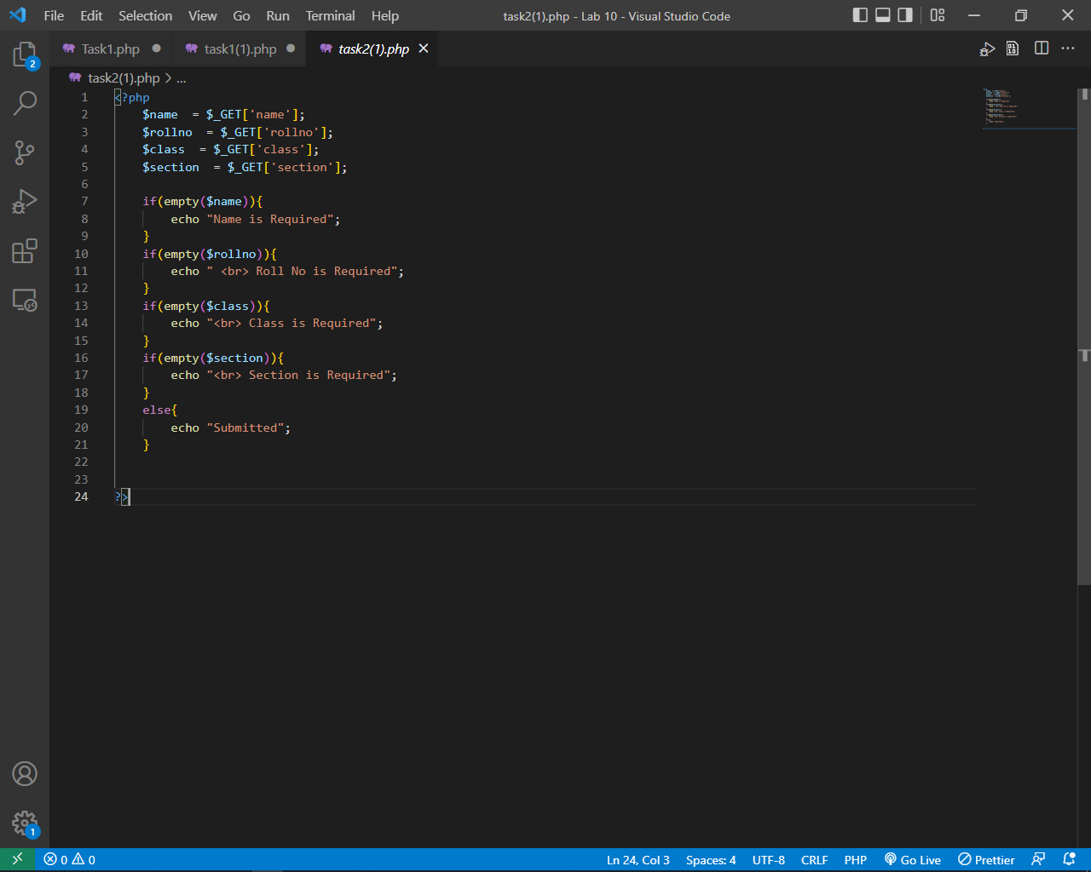

File # 2

**Output:**

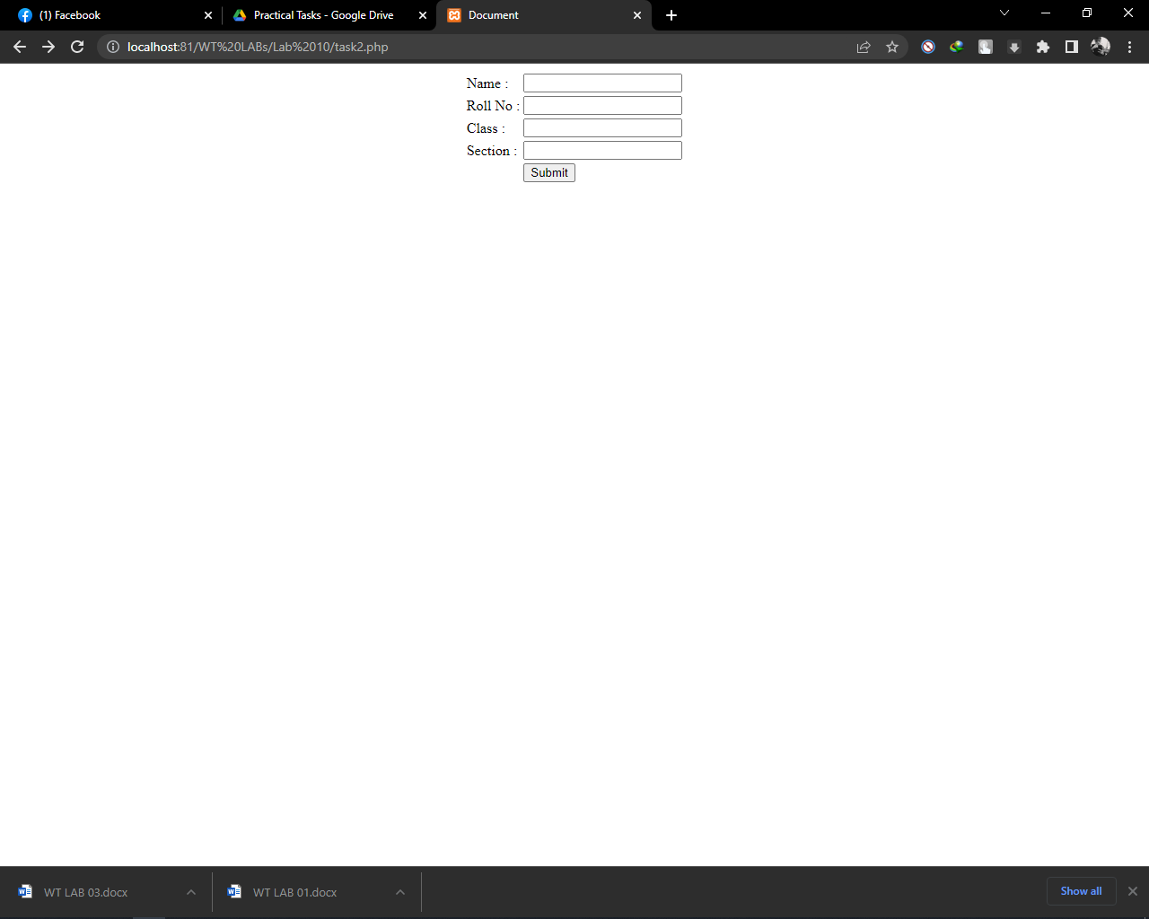

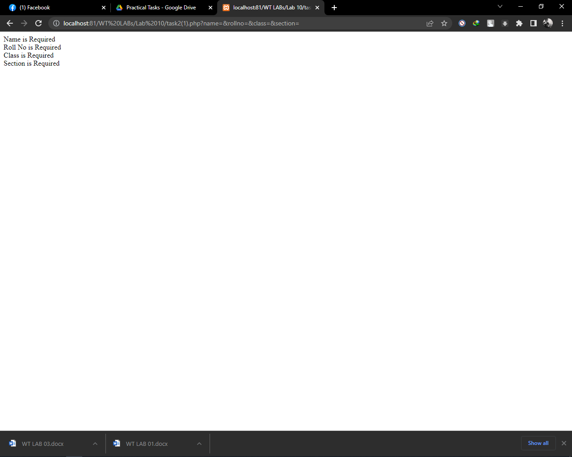

**Task #3:** Create Simple 3 Step Form using PHP. In First file take inputs using form, in second step show option for modify or submit form in third step show a successful submission and redirect it to first file.

**Task #4:** Write a program to calculate and print the factorial of a number using for loop.

**Code:**

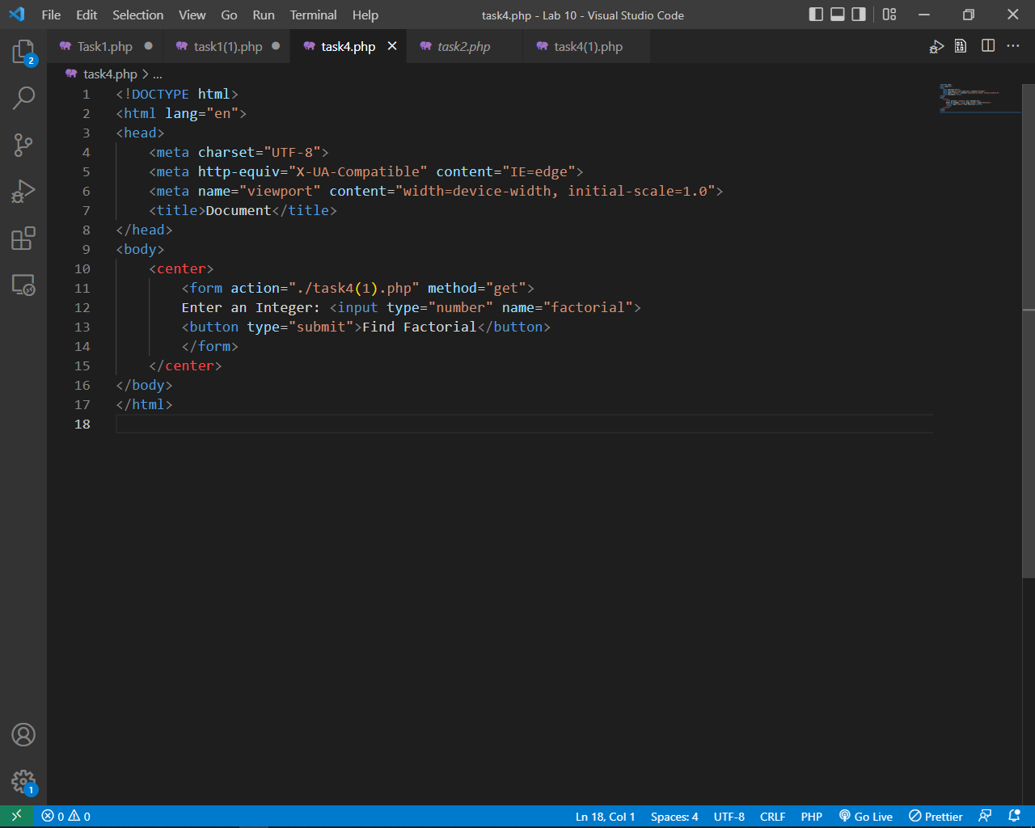

File # 1

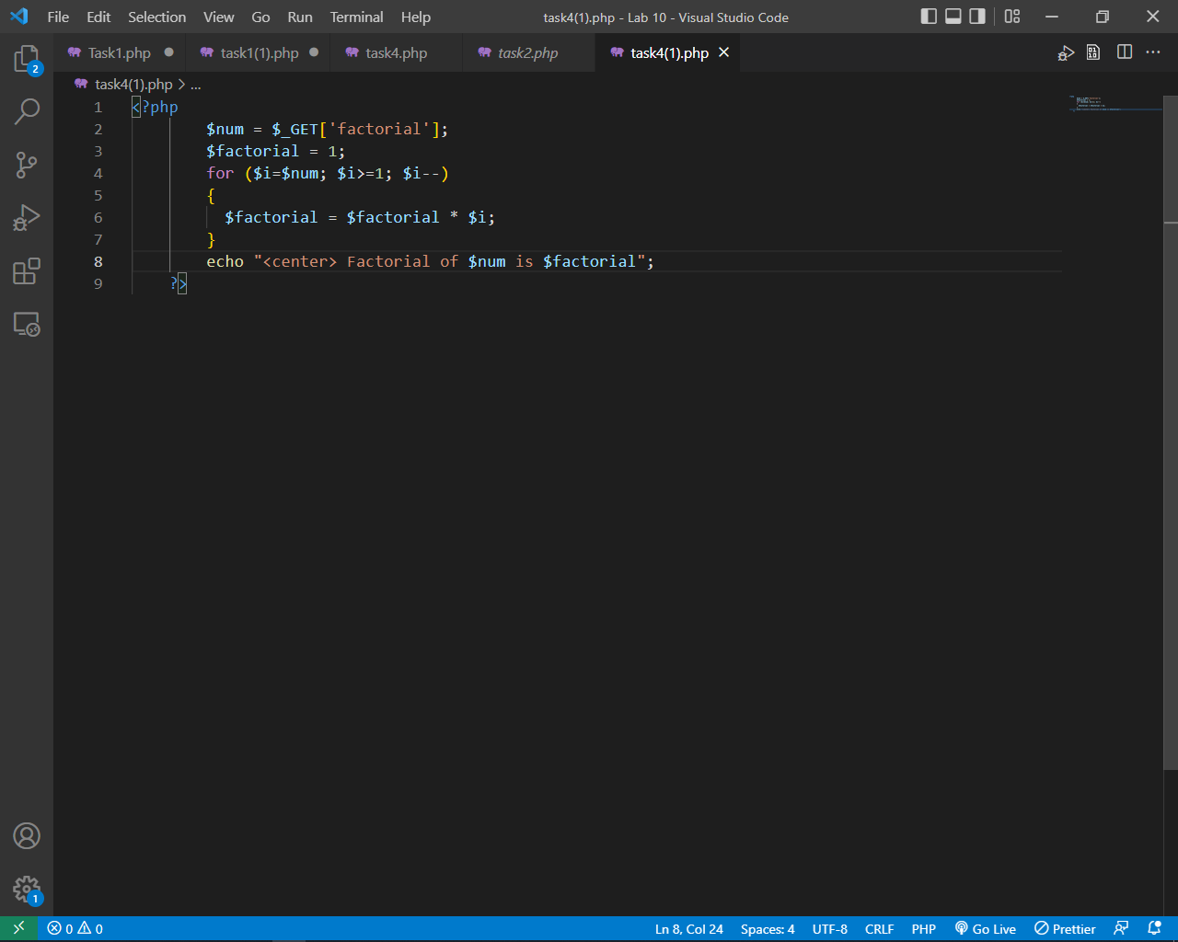

File # 2

**Output:**

